Requirements Analysis Document
Car Rental System - CRS
CSCI 4711 Software Engineering
Fall 2017
Augusta University
Augusta, GA
Date: 9/20/2017
Version 1

Team Members

James Rowland
Rebe LeGoullon
Adam Perry
Mitchell Williams
Jessie Siebeck

Abstract
This document contains the information regarding the design artifacts, requirements and analysis of the Car Rental System or CRS. The CRS is an application for Car rental services can deploy to electronically manage their customer rentals. This system is designed to assist employees in their day-to-day task.
The RentalAgent or Technician will be able to keep track of inventory and any damages that occur to the vehicles though their own respective controls. The RentalAgent will assist the customer in the pickup process by selecting a car from an available inventory list. From there the RentalAgent will be able to see any damage that has occurred, license plate, and other information regarding the car. They also will get customer information to store such as insurance, credit card, and license and contact information. The Technician will be able to see any previous damage listed as well and after assessing the car upon return report new damage. If any new damage occurs the Technician will be able to give an estimated cost of repair and submit the car back in the inventory.
This document describes the analysis, design artifacts and requirements of the Car Rental System and is structured as follows. Chapter 1 contains an introduction, a brief overview of the application. Chapter 2 outlines our functional requirements of the application and gives use case examples and descriptions. Chapter 3 shows intended mockups of the application to help demonstrate information in Chapter 2.

Table of Contents

1 | INTRODUCTION……………………………………………............. |  |  | 4
 | 1.1 | SCOPE OF SYSTEM………………………………………………… | 4
 | 1.2 | OVERVIEW OF DOCUMENT……………………………………… | 5
2 | REQUIREMENTS OF SYSTEM……………………………………. |  |  | 6
 | 2.1 | FUNCTIONAL REQUIREMENTS………………………………….. | 6
 | 2.2 | USE CASES………………………………………………………….. | 7
 | 2.3 | USE CASE DESCRIPTIONS………………………………………... | 8
 | 2.4 | REQUIREMENTS ANALYSIS
3 | SER INTERFACE MOCKUPS……………………...….…………. |  |  | 21
 | 3.1 | LOGIN………………………………………………………………... | 21
 | 3.2 | LOGOUT………………………………………………………………... | 23
 | 3.3 | PICKUP…………………………………….……….. | 24
 | 3.4 | RETURN……...…………………………………… | 26

Introduction

Scope of System
Car Rental Systems is a centralized information system for vehicle inventory management, customer information storage, and car rental services. The actors associated with the system are as follows: the RentalAgent is responsible for car rental pickups and the collection of customer information, and the Technician handles the return process for car rentals, as well as assessing and applying additional charges due to vehicular damage incurred while in the customer’s care. The RentalAgent can view available cars in the inventory and rent the vehicle to a customer. The Technician can view a vehicle’s record and return the customer’s rental in the system.
The system supports both actors by maintaining an up to date list of available cars in the inventory, allowing the RentalAgent to process rental pickups and store customer information, as well as cancel rental requests before completion. The system is capable of accessing the customer information stored in a database and charging the customer the total rental cost using the customer’s stored payment information upon return of the rental. The RentalAgent and the Technician actors interact with the Car Rental System through separate interfaces, limiting their tasks based on their user type.
The system includes functionality for verifying users, managing vehicle information, as well as facilitating car rentals and returns and processing customer payments. Both the RentalAgent and Technician can log in and out of the system. Only the RentalAgent is capable of viewing the PickupRental interface and only the Technician can view the ReturnRental interface. All data stores are internal and part of the system. The system is stand-alone, and any external interaction is restricted to RentalAgent and Technician users only.

overview of document
The rest of this document is structured as follows. Chapter 2 outlines the functional requirements of the system. Within this chapter is a list of functional requirements of the Car Rental System. It also includes a use case model of those functional requirements. A detailed description of each functional requirement then follows.

requirements of system

Functional Requirements
- Login – All users of the system must login to verify that they are an employee of Car Rental Systems as either a RentalAgent or a Technician. This function verifies the user and grants them access to other functionality.
- Logout – This allows users of the system to logout. This closes the connection to the system and prevents unauthorized use.
- PickupRental – This function allows a RentalAgent of Car Rental Systems to rent an available vehicle to a customer and record a customer’s contact and payment information. The RentalAgent is able to cancel a rental during this process.
- ReturnRental – This function allows Technicians to process rental returns and apply any additional costs due to vehicular damage incurred during the customer’s possession.

use cases
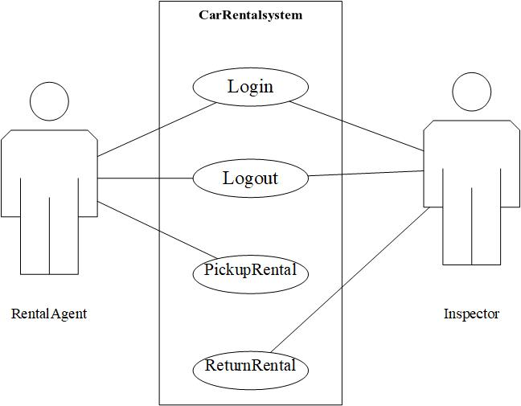

Figure 2.1 use case diagram for Car Rental System

use case descriptions
Use case name | Login
Participating  Actors | Initiated by RentalAgent and Technician
Flow of events | - “Login” functionality is activated when the user fills out the login form and pushes the submit button on the login form. The login form contains a field for a username and a field for a password.  - Software receives the form and verifies the username and username and password. The information is valid. The user is logged in, and is displayed their respective homepages.
Entry condition
Exit condition | The user is logged in and displayed their homepage.
Security  requirements | 1. The password field should not display any text.  2. All SQL queries should be structured to prevent SQL injections.
Figure 2.2 Login: Valid Credentials

Use case name | Login
Participating  actors | Initiated by RentalAgent and Technician
Flow of events | - “Login” functionality is activated when the user fills out the login form and pushes the submit button on the login form. The login form contains a field for a username and a field for a password.  - Software receives the form and verifies the username and username and password. The information is not valid. The following error message is displayed on the login form:  “Invalid username and password”
Entry condition
Exit condition | An error message is displayed on login form.
Security  requirements | 1. The password field should not display any text.  2. All SQL queries should be structured to prevent SQL injections.
Figure 2.3: Login: Invalid Credentials

Use case name | Logout
Participating  Actors | Initiated by RentalAgent and Technician
Flow of events | - The logout button is pressed from the user’s homepage.  - The software displays a message asking the user if they are certain they wish to logout. A logout and a cancel button is presented with the message.  - The user presses the logout button.  - The user is logged out from the software and presented the login page.
Entry condition | The User is logged in.
Exit condition | The user is logged out and presented the login page.
Security
requirements
Figure 2.4 Logout: Confirmed

Use case name | Logout
Participating  actors | RentalAgent and Technician
Flow of events | - The logout button is pressed from the user’s homepage.  - The software displays a message asking the user if they are certain they wish to logout. A logout and a cancel button is presented with the message.  - The user presses the cancel button.  - The user is presented back to their homepage.
Entry condition | The User is logged in.
Exit condition | The user is presented back to their homepage.
Security
requirements
Figure 2.5 Logout: Canceled

Use case name | PickupRental
Participating  actors | Initiated by Rental Agent
Flow of events | - This function is activated when a user selects the “Rental” button on the Rental Agent Homepage.  - System presents the Vehicle Selection screen for the Rental Agent to select which available vehicle is to be rented.  - Rental Agent and customer go over available vehicles based on Make, Model, Year, and Price per Day. Once selection is made, the Rental Agent uses the “Next” button on the Car Selection screen.  - System presents the Vehicle Information form for Rental Agent to review the vehicle description prior to rental.  - Rental Agent approves the vehicle for rental by selecting the “Approve” button.  - System presents the Customer Information screen for the Rental Agent to confirm information and submit to finalize rental.  - Rental Agent enters the customer’s information into correct fields, including payment information, then finalizes rental by selecting the “Submit” button.  - System schedules rental and displays Rental Agent home screen.
Entry condition | - The “Rental” button is Selected from the Rental Agent home page.
Exit condition | - Rental is scheduled.  - The Rental Agent Homepage is displayed.
Security  requirements | - Validate form data
Figure 2.6: Pickup Rental: Rental Confirmed

Use case name | PickupRental
Participating  actors | Initiated by Rental Agent
Flow of events | - This function is activated when a user selects the “Rental” button on the Rental Agent Homepage.  - System presents the Vehicle Selection screen for the Rental Agent to select which available vehicle is to be rented.  - Customer cancels mid process while on Car Selection Screen. Rental Agent selects “Cancel” button.  - System presents Rental Agent Homepage.
Entry condition | - The “Rental” button is clicked from the Rental Agent homescreen
Exit condition | - Rental is canceled.  - The Rental Agent homepage is displayed.
Security
requirements
Figure 2.7: Pickup Rental: Rental Canceled

Use case name | ReturnRental
Participating  Actors | Initiated by Technician
Flow of Events | - This function is activated when a Technician selects the Return button on the Technician homepage.  - System presents the Information Lookup form with a field for a license plate number.  - User enters license plate number of a vehicle that is being returned and presses “Enter”.  - System presents vehicle information, including make, model, year, customer name, and due date on the form.  - The user selects “Return Vehicle” to confirm return.  - System presents the Vehicle Review screen for the Technician to view the details of the car and is provided with the options to select Report or Approve.  - Technician compares the details in Vehicle Description to the incoming vehicle. No damage is present, so the Technician selects the approve button.  - The system marks the vehicle as returned and displays Technician homepage.
Entry condition | The “Return Vehicle” button is clicked from the Technician Homepage.
Exit condition | Return is approved.  The Technician homepage is displayed.
Security
requirements
Figure 2.8: Approved with no Damages

Use case name | ReturnRental
Participating  Actors | Initiated by Technician
Flow of Events | - This function is activated when a Technician selects the Return Vehicle button on the Technician homepage.  - System presents the Information Lookup form with a field for a license plate number.  - User enters license plate number of a vehicle that is being returned and presses “Enter”.  - System presents vehicle information, including make, model, year, customer name, and due date to the form.  - The user selects “Return Vehicle” to confirm return.  - System presents the Vehicle Review screen for the Technician to view the details of the car and is provided with the options to select Report or Approve.  - Technician compares the details in Vehicle Description to the incoming vehicle. If new damage is found, the Technician selects Report.  - System presents the Vehicle Damage screen where the Technician can report the details of the damage.  - Technician enters a description of the vehicle damage and a value for the estimated cost of repair, and then selects Approve.  - System marks vehicle as damaged and returned and displays Technician homepage.
Entry condition
Exit condition | Return is approved.  The Technician homepage is displayed.
Security
requirements
Figure 2.9 Return: Approved with Damages

Use case name | ReturnRental
Participating  Actors | Initiated by Technician
Flow of Events | - This function is activated when a Technician selects the Return Vehicle button on the Technician homepage.  - System presents the Information Lookup form with a field for a license plate number.  - User presses “Cancel” on the form during interaction.  - System returns to the Technician homepage.
Entry condition | The “Cancel” button is clicked on the license form.
Exit condition | The Technician homepage is displayed.
Security
requirements
Figure 2.10 Return: Canceled

2.4 REQUIREMENTS ANALYSIS

This page intentionally left blank

Figure 2.11 Login: Valid Credentials (checked)

Figure 2.12 Login: Invalid Credentials (checked)

Figure 2.13 Logout: Confirmed (checked)

Figure 2.14 Logout: Canceled (checked)

Figure 2.15 Pickup: Rental Confirmed (checked)

Figure 2.16 Pickup: Rental Canceled (checked)

Figure 2.17 Return: Approved with no Damages

Pickup 2.18 Return: Approved with Damages (Check)

Figure 2.19 Return: Canceled

USER INTERFACE MOCKUPS

Login
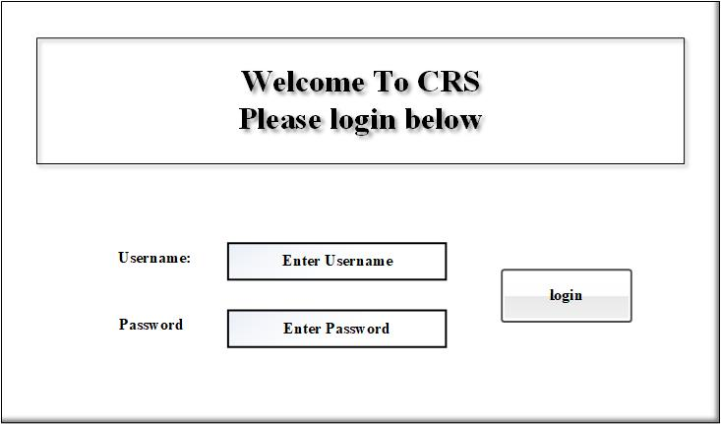
Figure 3.1: Login
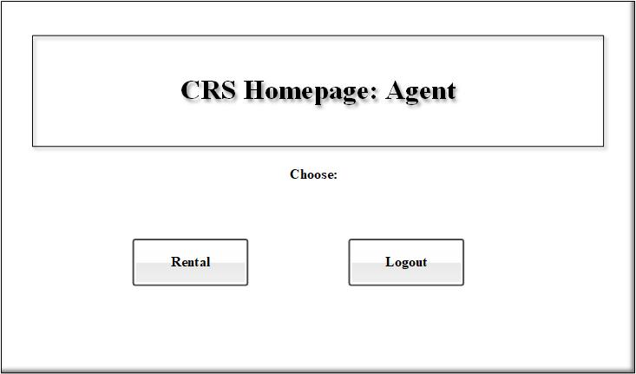
Figure 3.2: Agent Homepage

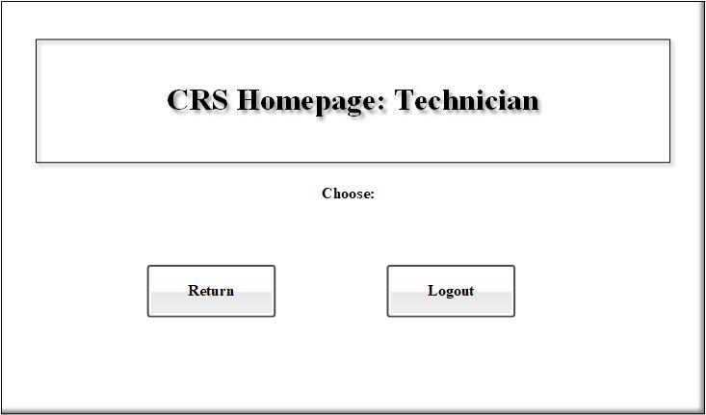
Figure 3.3: Technician Homepage

Logout
Rental Agent: Refer to Figure 3.2: Rental Agent Homepage on page 17 of this document.

Technician: Refer to Figure 3.3: Technician Homepage on page 18 of this docuent.

Pickup
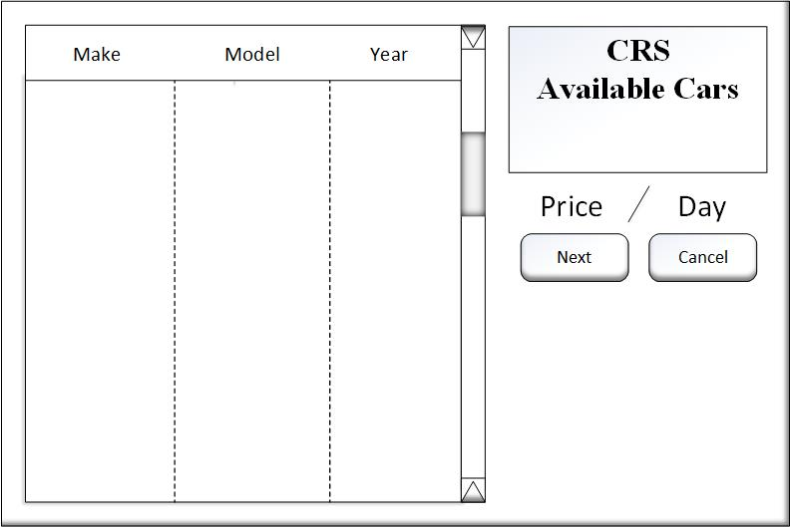
Figure 3.4 Pickup: Vehicle Selection

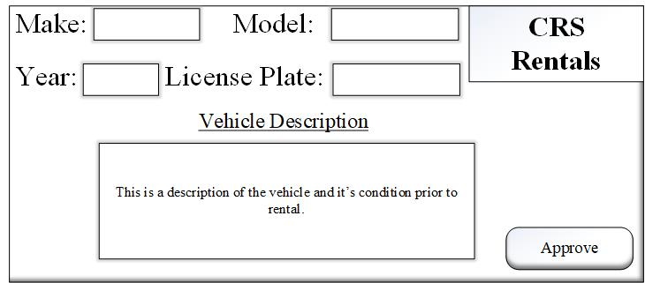
Figure 3.5 Pickup: Vehicle Information

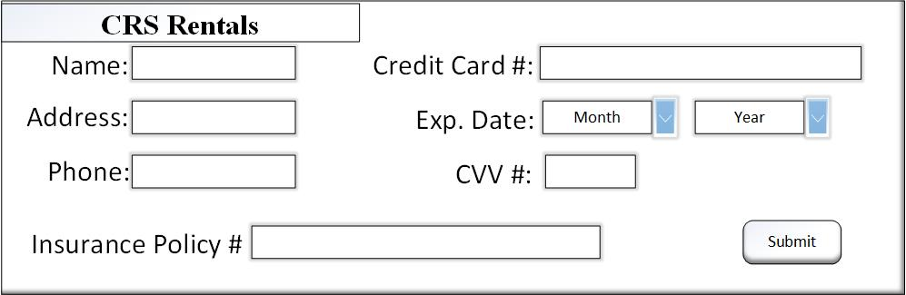
Figure 3.6 Pickup: Customer Information

Return
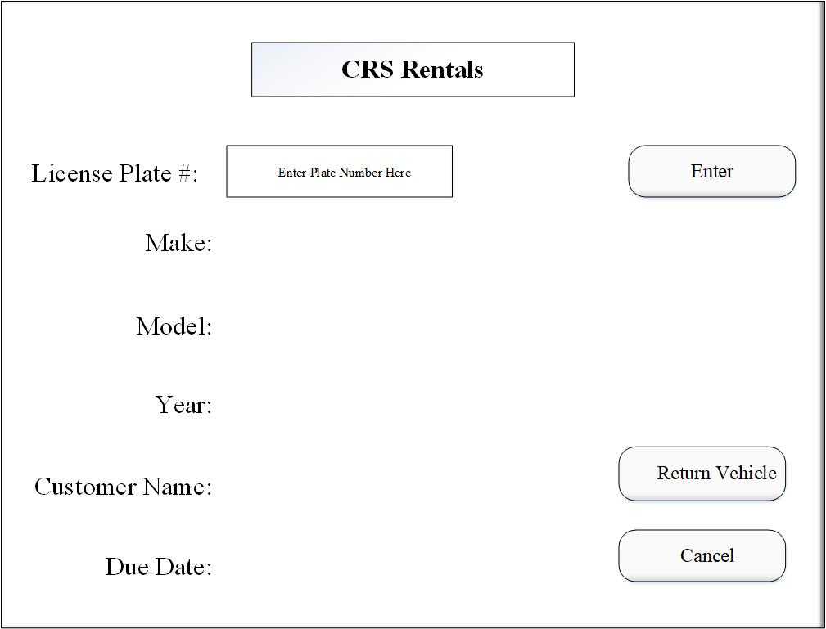
Figure 3.7 Return: Information Lookup

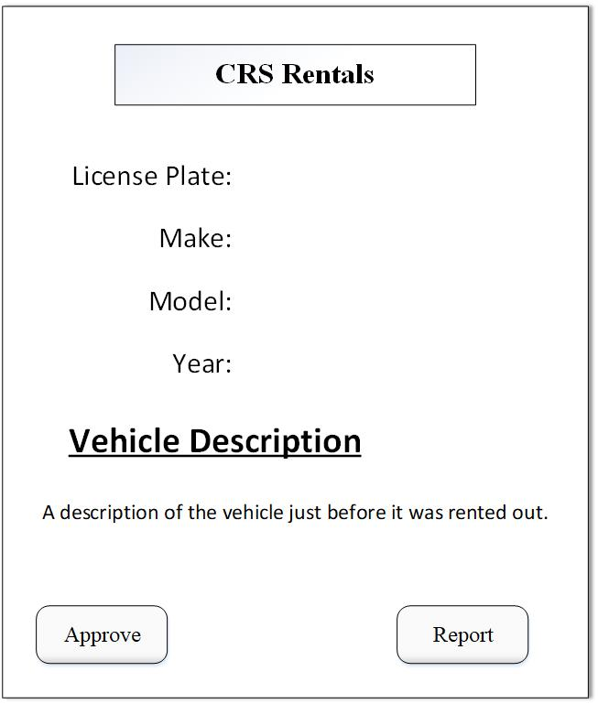
Figure 3.8: Vehicle Review Screen

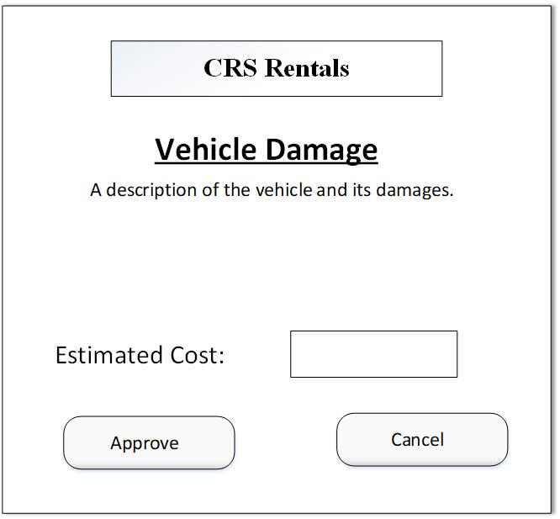
Figure 3.9 Return: Damage Report

